Speak Ease (Duolingo Clone)

1. Introduction
Learning a new language can be difficult without proper guidance, structured lessons, and regular practice. Many learners struggle to stay consistent because they do not have access to interactive exercises, quizzes, and progress tracking systems. Speak Ease solves this problem by providing a user-friendly language learning platform where users can learn languages step by step.
Speak Ease helps users practice vocabulary, grammar, pronunciation, reading, and listening skills through interactive lessons and quizzes. It is designed to make language learning simple, engaging, and enjoyable.

2. Description
Speak Ease is a language learning platform inspired by Duolingo and built using the MERN Stack (MongoDB, Express.js, React.js, Node.js). The platform allows users to select a language they want to learn and complete structured lessons and exercises.
The system provides different learning modules such as vocabulary practice, sentence formation, grammar exercises, listening tasks, and quizzes. Each lesson contains multiple activities that help learners understand concepts step by step.
Users can track their learning progress, earn badges, unlock new lessons, and review completed exercises. The application also provides instant feedback for quiz answers, helping learners improve quickly.
The admin panel allows administrators to manage courses, create lessons, upload learning materials, and monitor user activity. Speak Ease creates an engaging environment for learners while giving administrators complete control over the platform.

3. Scenario-Based Case Study
Sarah wants to learn Spanish for travel purposes. She downloads Speak Ease and creates an account.
- User Registration/Login: Sarah signs up using her email and password.
- Language Selection: She chooses Spanish as the language she wants to learn.
- Lesson Browsing: Sarah sees beginner-level lessons like greetings, numbers, colors, and daily phrases.
- Vocabulary Practice: She completes flashcard activities for Spanish words.
- Quiz Participation: Sarah takes quizzes after each lesson to test her understanding.
- Progress Tracking: The system shows her completed lessons, quiz scores, and learning streak.
- Achievement Badges: After completing five lessons, Sarah unlocks a “Beginner Learner” badge.
- Admin Support: Administrators can update lesson content and add new exercises regularly.

4. Technical Architecture
The Speak Ease platform consists of several important components:
- User Interface: Provides an interactive frontend where users can browse lessons, take quizzes, and track progress.
- Web Server: Hosts the React frontend and serves dynamic pages.
- API Gateway: Handles communication between frontend and backend services.
- Authentication Service: Manages secure user login, registration, and authorization.
- Database: Stores user profiles, lessons, quizzes, progress data, and achievements in MongoDB.
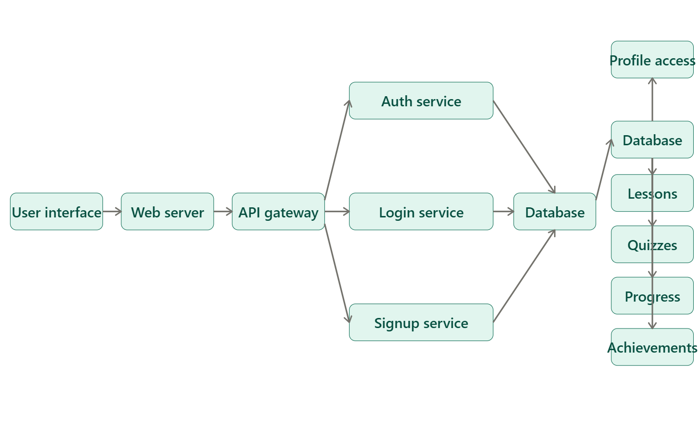
- Lesson Management Service: Handles lesson creation, updates, and categorization.
- Quiz Service: Evaluates quiz answers and provides scores and feedback.
- Progress Tracking Service: Monitors completed lessons, streaks, and user achievements.

5. ER-Diagram & Relationships
The main entity relationships in Speak Ease are:
- User-Lesson Relationship: One-to-Many relationship where one user can complete multiple lessons.
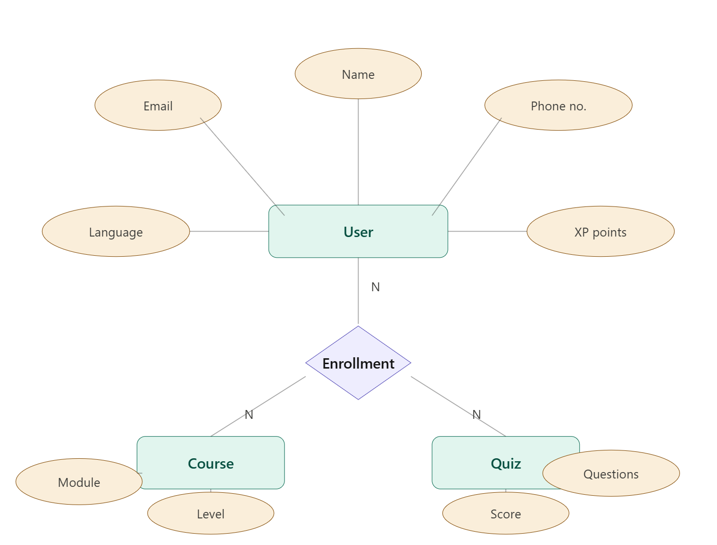
- Lesson-Quiz Relationship: One-to-Many relationship where one lesson can have multiple quizzes.
- User-Progress Relationship: One-to-One relationship where each user has a progress record.
- Admin-Course Relationship: One-to-Many relationship where admins can create multiple courses and lessons.These relationships help maintain structured data and improve platform functionality.
6. Project Flow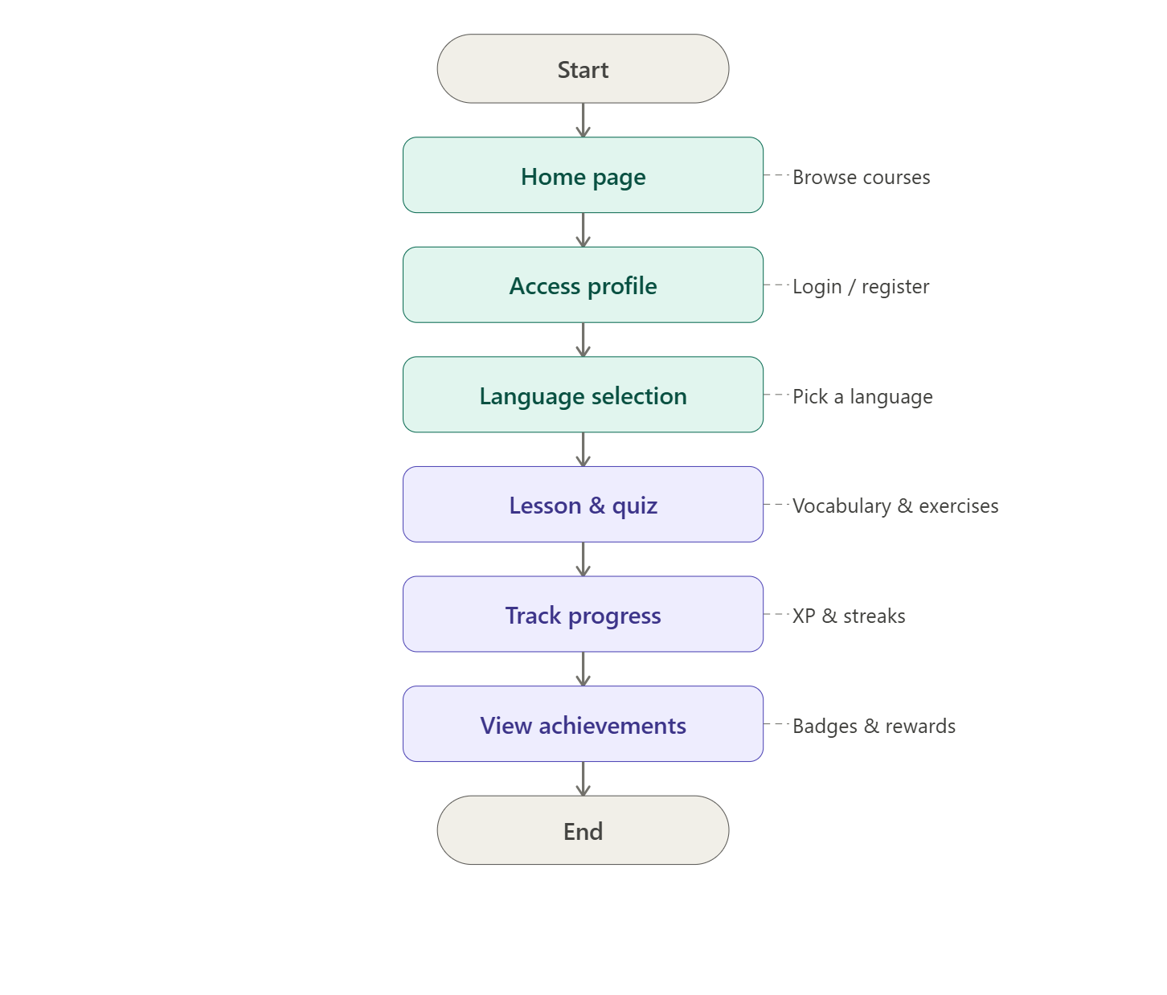
Users open Speak Ease → Register/Login → Select Language → Browse Lessons → Complete Exercises → Attempt Quizzes → Track Progress → Unlock Achievements → Logout.
Admins login → Manage Courses → Add Lessons → Upload Quiz Questions → Monitor User Progress → Update Learning Materials.

7. Pre-Requisites
Students should know:
- Basics of JavaScript
- ES6 Concepts
- Node.js fundamentals
- Express.js basics
- MongoDB basics
- REST APIs
- Basic React
- JSON and API handling
- State management basics

8. Required Technologies
- Frontend: React.js, HTML, CSS
- Backend: Node.js, Express.js
- Database: MongoDB
- Authentication & Security: JWT, bcrypt
- Tools: Postman, Git, GitHub
- Optional: Speech API for pronunciation practice
- Optional: Chart.js for progress analytics

9. Suggested Database Collections

Users Collection
{
"name": "Sarah",
"email": "sarah@example.com",
"password": "hashed_password",
"role": "user"
}

Languages Collection
{
"languageName": "Spanish",
"level": "Beginner",
"description": "Basic Spanish lessons for beginners"
}

Lessons Collection
{
"title": "Greetings in Spanish",
"description": "Learn basic greetings and introductions",
"languageId": "language_id_reference",
"difficulty": "Beginner"
}

Quizzes Collection
{
"lessonId": "lesson_id_reference",
"question": "What is the Spanish word for Hello?",
"options": ["Hola", "Bonjour", "Ciao", "Hallo"],
"correctAnswer": "Hola"
}

Progress Collection
{
"userId": "user_id_reference",
"completedLessons": 5,
"quizScore": 80,
"streakDays": 7,
"badges": ["Beginner Learner"]
}

10. Key Features
- User Authentication (Signup/Login)
- Language Selection
- Lesson Modules
- Vocabulary Practice
- Grammar Exercises
- Quizzes and Tests
- Progress Tracking
- Achievement Badges
- Learning Streaks
- Admin Dashboard
- Lesson Management
- Quiz Management
- User Performance Reports

11. Optional Advanced Features
- Pronunciation Practice using Speech Recognition
- Audio-Based Lessons
- Daily Learning Reminders
- Leaderboard System
- Gamification Features
- Social Sharing of Achievements
- AI-Based Learning Recommendations
- Real-time Chat Support
- Dark Mode
- Multi-language Interface

12. Learning Outcomes
By completing this project, students will learn:
- Full Stack Development (Frontend + Backend)
- REST API Design
- Authentication & Authorization using JWT
- MongoDB Database Design
- React State Management
- Building Quiz Systems
- Progress Tracking Systems
- Role-Based Access Control
- Real-world Project Structure
- Deployment Basics

13. Roles and Responsibilities

User
- Register and login securely
- Select a language course
- Complete lessons and quizzes
- Track learning progress
- Earn badges and achievements
- View performance reports
- Logout from the system

Admin
- Manage users and courses
- Add, update, and delete lessons
- Create quizzes and exercises
- Track user performance
- Generate reports
- Manage badges and achievements
- Maintain platform content and updates

